**Java - Introduction to Programming**

**Lecture 1**

**Installation & First Program**

1. **Install Java**

a. Install JDK ([https://www.oracle.com/in/java/technologies/javase-downloads.html](https://www.google.com/url?q=https://www.google.com/url?q%3Dhttps://www.oracle.com/in/java/technologies/javase-downloads.html%26amp;sa%3DD%26amp;source%3Deditors%26amp;ust%3D1688804980567840%26amp;usg%3DAOvVaw1GWiamVSAtb4EkaFD2KRFh&sa=D&source=docs&ust=1688804980578614&usg=AOvVaw1D-aLFwpiIZdY7CUBJnF0Y))

b. Install IntelliJ ([https://www.jetbrains.com/idea/download/#section=mac](https://www.google.com/url?q=https://www.google.com/url?q%3Dhttps://www.jetbrains.com/idea/download/%2523section%253Dmac%26amp;sa%3DD%26amp;source%3Deditors%26amp;ust%3D1688804980568033%26amp;usg%3DAOvVaw0K4ZC2Ih1fkHUSfIiibu8x&sa=D&source=docs&ust=1688804980578792&usg=AOvVaw3G6yegmL_XdeXipEd-x52v))

                OR

b. Install Visual Studio Code (VS Code) - Prefer THIS ([https://code.visualstudio.com/download](https://www.google.com/url?q=https://www.google.com/url?q%3Dhttps://code.visualstudio.com/download%26amp;sa%3DD%26amp;source%3Deditors%26amp;ust%3D1688804980568228%26amp;usg%3DAOvVaw1v7JD1M9IMnZFBnEJpiI02&sa=D&source=docs&ust=1688804980578916&usg=AOvVaw3YSueCRLoOP1VIvK2fG27Z))

1. **Sample Code**

**Functions**

A function is a block of code which takes some input, performs some operations and returns some output.

The functions stored inside classes are called methods.

***The function we have used is called main.***

**Class**

A class is a group of objects which have common properties. A class can have some properties and functions (called methods).

***The class we have used is Main.***

1. **Our 1st Program**

**public class Main {**

**public static void main(String[] args) {**

**// Our 1st Program**

**System.*out*.println("Hello World");**

**}**

**}**

**Java - Introduction to Programming**

**Lecture 2**

**Variables & Data Types**

1. **Variables**

A variable is a container (storage area) used to hold data.

Each variable should be given a unique name (identifier).

package com.apnacollege;

public class Main {

   public static void main(String[] args) {

      // Variables

       String name = "Aman";

       int age = 30;

       String neighbour = "Akku";

       String friend = neighbour;

   }

}

1. **Data Types**

Data types are declarations for variables. This determines the type and size of data associated with variables which is essential to know since different data types occupy different sizes of memory.

There are 2 types of Data Types:

* Primitive Data types: to store simple values
* Non-Primitive Data types: to store complex values

**Primitive Data Types**

These are the data types of fixed size.

|  |  |  |  |
| --- | --- | --- | --- |
| **Data Type** | **Meaning** | **Size**  **(in Bytes)** | **Range** |
| byte | 2’s complement integer | 1 | -128 to 127 |
| short | 2’s complement integer | 2 | -32K to 32K |
| int | Integer numbers | 4 | -2B to 2B |
| long | 2’s complement integer  (larger values) | 8 | -9,223,372,036,854,775,808  to 9,223,372,036,854,775,807 |
| float | Floating-point | 4 | Up to 7 decimal digits |
| double | Double Floating-point | 8 | Up to 16 decimal digits |
| char | Character | 2 | a, b, c… A, B, C...  @, #, $ .. |
| bool | Boolean | 1 | True, false |

**Non-Primitive Data Types**

These are of variable size & are usually declared with a ‘new’ keyword.

        Eg: String, Arrays

        String name = new String("Aman");

int[] marks = new int[3];

marks[0] = 97;

marks[1] = 98;

marks[2] = 95;

1. **Constants**

A constant is a variable in Java which has a fixed value i.e. it cannot be assigned a different value once assigned.

package com.apnacollege;

public class Main {

   public static void main(String[] args) {

  // Constants

       final float PI = 3.14F;

   }

}

**Homework Problems**

1. **Try to declare meaningful variables of each type. Eg - a variable named age should be a numeric type (int or float) not byte.**
2. **Make a program that takes the radius of a circle as input, calculates its radius and area and prints it as output to the user.**
3. **Make a program that prints the table of a number that is input by the user.**

**(HINT - You will have to write 10 lines for this but as we proceed in the course you will be studying about ‘LOOPS’ that will simplify your work A LOT!)**

**Java - Introduction to Programming**

**Lecture 3**

1. **Conditional Statements ‘if-else’**

The if block is used to specify the code to be executed if the condition specified in if is true, the else block is executed otherwise.

int age = 30;

if(age > 18) {

   System.*out*.println("This is an adult");

} else {

   System.*out*.println("This is not an adult");

}

1. **Conditional Statements ‘switch’**

Switch case statements are a substitute for long if statements that compare a

variable to multiple values. After a match is found, it executes the

corresponding code of that value case.

The following example is to print days of the week:

int n = 1;

switch(n) {

   case 1 :

       System.*out*.println("Monday");

       break;

   case 2 :

       System.*out*.println("Tuesday");

       break;

   case 3 :

       System.*out*.println("Wednesday");

       break;

   case 4 :

       System.*out*.println("Thursday");

       break;

   case 5:

       System.*out*.println("Friday");

       break;

   case 6 :

       System.*out*.println("Saturday");

       break;

   default :

       System.*out*.println("Sunday");

}

**Homework Problems**

1. Make a Calculator. Take 2 numbers (a & b) from the user and an operation as follows:

        1: + (Addition) a + b

* 2: - (Subtraction) a - b
* 3: * (Multiplication) a * b
* 4: / (Division) a / b
* 5: % (Modulo or remainder) a % b

Calculate the result according to the operation given and display it to the user.

1. Ask the user to enter the number of the month & print the name of the month. For eg - For ‘1’ print ‘January’, ‘2’ print ‘February’ & so on.

**Java - Introduction to Programming**

**Lecture 4**

**Loops**

A loop is used for executing a block of statements repeatedly until a particular condition is satisfied. A loop consists of an initialization statement, a test condition and an increment statement.

**For Loop**

The syntax of the for loop is:

for (initialization; condition; update) {

 // body of-loop

}

for (int i=1; i<=20; i++) {

   System.*out*.println(i);

}

**While Loop**

The syntax for while loop is:

while(condition) {

 // body of the loop

}

int i = 0;

while(i<=20) {

   System.*out*.println(i);

   i++;

}

**Do-While Loop**

The syntax for the do-while loop is:

do {

 // body of loop;

}

while (condition);

int i = 0;

do {

   System.*out*.println(i);

   i++;

} while(i<=20);

**Homework Problems**

1. Print all even numbers till n.
2. Run

for(; ;) {

            System.out.println("Apna College");

        }

loop on your system and analyze what happens. Try to think of the reason for the output produced.

1. Make a menu driven program. The user can enter 2 numbers, either 1 or 0.

If the user enters 1 then keep taking input from the user for a student’s marks (out of 100).

If they enter 0 then stop.

If he/ she scores:

**Marks >=90** -> print “This is Good”

**89 >= Marks >= 60** -> print “This is also Good”

**59 >= Marks >= 0** -> print “This is Good as well”

        Because marks don’t matter but our effort does.

(Hint: use do-while loop but think & understand why)

**BONUS**

Qs. Print if a number is prime or not (Input n from the user).

[In this problem you will learn how to check if a number is prime or not]

**Homework Solution (Lecture 3)**

**import java.util.*;**

**public class Conditions {**

**public static void main(String args[]) {**

**Scanner sc = new Scanner(System.in);**

**int a = sc.nextInt();**

**int b = sc.nextInt();**

**int operator = sc.nextInt();**

**/\*\***

**\* 1 -> +**

**\* 2 -> -**

**\* 3 -> \***

**\* 4 -> /**

**\* 5 -> %**

**\*/**

**switch(operator) {**

**case 1 : System.out.println(a+b);**

**break;**

**case 2 : System.out.println(a-b);**

**break;**

**case 3 : System.out.println(a*b);**

**break;**

**case 4 : if(b == 0) {**

**System.out.println("Invalid Division");**

**} else {**

**System.out.println(a/b);**

**}**

**break;**

**case 5 : if(b == 0) {**

**System.out.println("Invalid Division");**

**} else {**

**System.out.println(a%b);**

**}**

**break;**

**default : System.out.println("Invalid Operator");**

**}**

**}**

**}**

**Java - Introduction to Programming**

**Lecture 5**

**Patterns - Part 1**

* 1. 

import java.util.*;

public class Patterns {

   public static void main(String args[]) {

       int n = 5;

       int m = 4;

       for(int i=0; i<n; i++) {

           for(int j=0; j<m; j++) {

               System.out.print("*");

           }

           System.out.println();

       }

   }

}

1. 

import java.util.*;

public class Patterns {

   public static void main(String args[]) {

       int n = 5;

       int m = 4;

       for(int i=0; i<n; i++) {

           for(int j=0; j<m; j++) {

               if(i == 0 || i == n-1 || j == 0 || j == m-1) {

                   System.out.print("*");

               } else {

                   System.out.print(" ");

               }

           }

           System.out.println();

       }

   }

}

1. 

import java.util.*;

public class Patterns {

   public static void main(String args[]) {

       int n = 4;

       for(int i=1; i<=n; i++) {

           for(int j=1; j<=i; j++) {

                   System.out.print("*");

           }

           System.out.println();

       }

   }

}

1. 

import java.util.*;

public class Patterns {

   public static void main(String args[]) {

       int n = 4;

       for(int i=n; i>=1; i--) {

           for(int j=1; j<=i; j++) {

                   System.out.print("*");

           }

           System.out.println();

       }

   }

}

1. 

import java.util.*;

public class Patterns {

   public static void main(String args[]) {

       int n = 4;

       for(int i=n; i>=1; i--) {

           for(int j=1; j<i; j++) {

               System.out.print(" ");

           }

           for(int j=0; j<=n-i; j++) {

               System.out.print("*");

           }

           System.out.println();

       }

   }

}

1. 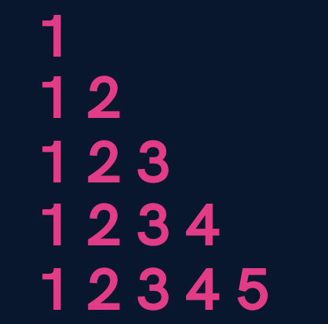

**import java.util.*;**

**public class Patterns {**

**public static void main(String args[]) {**

**int n = 5;**

**for(int i=1; i<=n; i++) {**

**for(int j=1; j<=i; j++) {**

**System.out.print(j);**

**}**

**System.out.println();**

**}**

**}**

**}**

1. 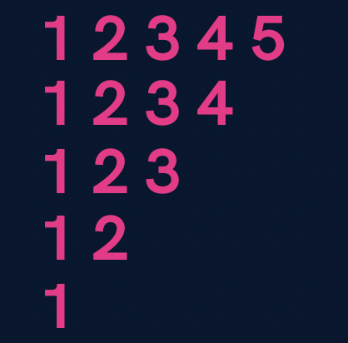

**import java.util.*;**

**public class Patterns {**

**public static void main(String args[]) {**

**int n = 5;**

**for(int i=n; i>=1; i--) {**

**for(int j=1; j<=i; j++) {**

**System.out.print(j);**

**}**

**System.out.println();**

**}**

**}**

**}**

1. 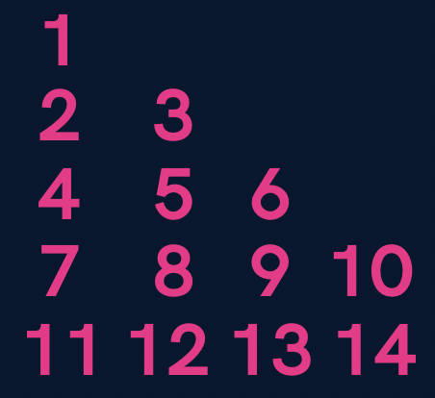

**import java.util.*;**

**public class Patterns {**

**public static void main(String args[]) {**

**int n = 5;**

**int number = 1;**

**for(int i=1; i<=n; i++) {**

**for(int j=1; j<=i; j++) {**

**System.out.print(number+" ");**

**number++;**

**}**

**System.out.println();**

**}**

**}**

**}**

1. 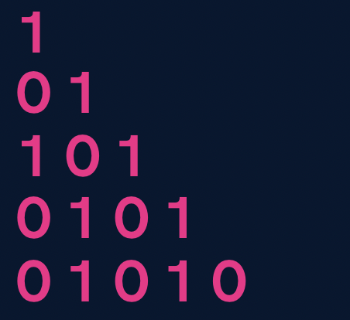

**import java.util.*;**

**public class Patterns {**

**public static void main(String args[]) {**

**int n = 5;**

**for(int i=1; i<=n; i++) {**

**for(int j=1; j<=i; j++) {**

**if((i+j) % 2 == 0) {**

**System.out.print(1+" ");**

**} else {**

**System.out.print(0+" ");**

**}**

**}**

**System.out.println();**

**}**

**}**

**}**

**Homework Problems (Solutions in next Lecture’s Video)**

1. Print a solid rhombus.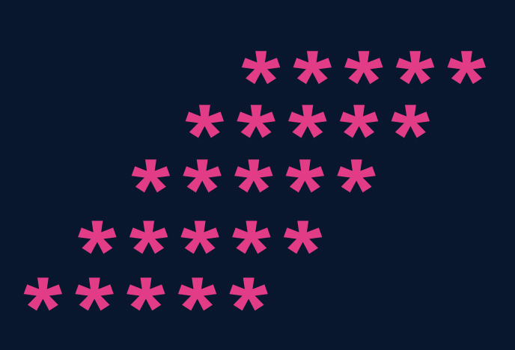
2. Print a number pyramid.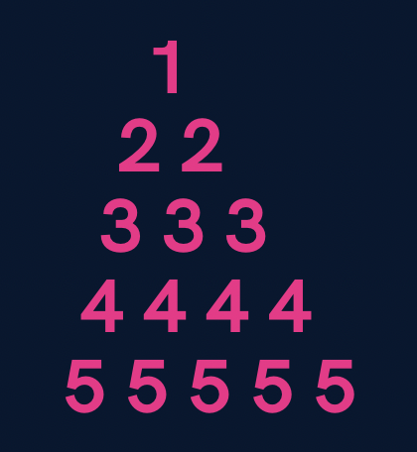
3. Print a palindromic number pyramid.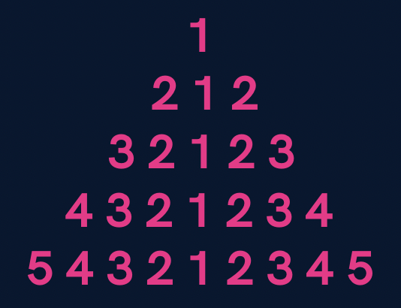

**Homework Solution (Lecture 4)**

1. Print all even numbers till n.
2. public class Solutions {
3. public static void main(String args[]) {
4. int n = 25;
5. for(int i=1; i<=n; i++) {
6. if(i % 2 == 0) {
7. System.out.println(i);
8. }
9. }
10. }
11. }

3. Make a menu driven program. The user can enter 2 numbers, either 1 or 0.

If the user enters 1 then keep taking input from the user for a student’s marks (out of 100).

If they enter 0 then stop.

If he/ she scores:

**Marks >=90** -> print “This is Good”

**89 >= Marks >= 60** -> print “This is also Good”

**59 >= Marks >= 0** -> print “This is Good as well”

        Because marks don’t matter but our effort does.

(Hint: use do-while loop but think & understand why)

**import java.util.*;**

**public class Solutions {**

**public static void main(String args[]) {**

**Scanner sc = new Scanner(System.in);**

**int input;**

**do {**

**int marks = sc.nextInt();**

**if(marks >= 90 && marks <= 100) {**

**System.out.println("This is Good");**

**} else if(marks >= 60 && marks <= 89) {**

**System.out.println("This is also Good");**

**} else if(marks >= 0 && marks <= 59) {**

**System.out.println("This is Good as well");**

**} else {**

**System.out.println("Invalid");**

**}**

**System.out.println("Want to continue ? (yes(1) or no(0))");**

**input = sc.nextInt();**

**} while(input == 1);**

**}**

**}**

Qs. Print if a number n is prime or not (Input n from the user).

[In this problem you will learn how to check if a number is prime or not]

**import java.util.*;**

**public class Solutions {**

**public static void main(String args[]) {**

**Scanner sc = new Scanner(System.in);**

**int n = sc.nextInt();**

**boolean isPrime = true;**

**for(int i=2; i<=n/2; i++) {**

**if(n % i == 0) {**

**isPrime = false;**

**break;**

**}**

**}**

**if(isPrime) {**

**if(n == 1) {**

**System.out.println("This is neither prime not composite");**

**} else {**

**System.out.println("This is a prime number");**

**}**

**} else {**

**System.out.println("This is not a prime number");**

**}**

**}**

**}**

**Java - Introduction to Programming**

**Lecture 6**

**Patterns - Part 2**

1. 

import java.util.*;

public class Solutions {

   public static void main(String args[]) {

       int n = 4;

       //upper part

       for(int i=1; i<=n; i++) {

           for(int j=1; j<=i; j++) {

               System.out.print("*");

           }

           int spaces = 2 * (n-i);

           for(int j=1; j<=spaces; j++) {

               System.out.print(" ");

           }

           for(int j=1; j<=i; j++) {

               System.out.print("*");

           }

           System.out.println();

       }

       //lower part

       for(int i=n; i>=1; i--) {

           for(int j=1; j<=i; j++) {

               System.out.print("*");

           }

           int spaces = 2 * (n-i);

           for(int j=1; j<=spaces; j++) {

               System.out.print(" ");

           }

           for(int j=1; j<=i; j++) {

               System.out.print("*");

           }

           System.out.println();

       }

   }

}

2. 

import java.util.*;

public class Solutions {

   public static void main(String args[]) {

       int n = 5;

       for(int i=1; i<=n; i++) {

           //spaces

           for(int j=1; j<=n-i; j++) {

               System.out.print(" ");

           }

           //stars

           for(int j=1; j<=n; j++) {

               System.out.print("*");

           }

           System.out.println();

       }

   }

}

3. 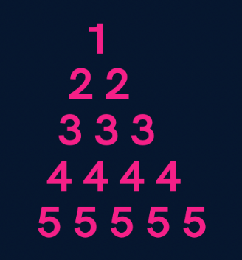

import java.util.*;

public class Solutions {

   public static void main(String args[]) {

       int n = 5;

       for(int i=1; i<=n; i++) {

           //spaces

           for(int j=1; j<=n-i; j++) {

               System.out.print(" ");

           }

           //numbers

           for(int j=1; j<=i; j++) {

               System.out.print(i+" ");

           }

           System.out.println();

       }

   }

}

4. 

import java.util.*;

public class Solutions {

   public static void main(String args[]) {

       int n = 5;

       for(int i=1; i<=n; i++) {

           //spaces

           for(int j=1; j<=n-i; j++) {

               System.out.print(" ");

           }

           //first part

           for(int j=i; j>=1; j--) {

               System.out.print(j);

           }

           //second part

           for(int j=2; j<=i; j++) {

               System.out.print(j);

           }

           System.out.println();

       }

   }

}

5. 

import java.util.*;

public class Solutions {

   public static void main(String args[]) {

       int n = 5;

       //upper part

       for(int i=1; i<=n; i++) {

           //spaces

           for(int j=1; j<=n-i; j++) {

               System.out.print(" ");

           }

           for(int j=1; j<=2*i-1; j++) {

               System.out.print("*");

           }

           System.out.println();

       }

       //lower part

       for(int i=n; i>=1; i--) {

           //spaces

           for(int j=1; j<=n-i; j++) {

               System.out.print(" ");

           }

           for(int j=1; j<=2*i-1; j++) {

               System.out.print("*");

           }

           System.out.println();

       }

   }

}

**Homework Problems**

1. **Print a hollow Butterfly.**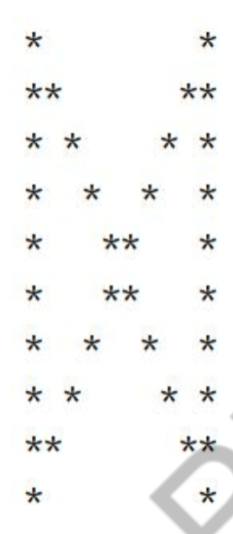
2. **Print a hollow Rhombus.**

    *****

   *      *

  *     *

 *     *

*****

1. **Print Pascal’s Triangle.**

    1

   1 1

  1 2 1

 1 3 3 1

1 4 6 4 1

1. **Print half Pyramid.**

    1

   1 2

  1 2 3

 1 2 3 4

* 1. 2 3 4 5

1. **Print Inverted Half Pyramid.**

11111

222

33

4

**Java - Introduction to Programming**

**Lecture 7**

**Methods/Functions**

A function is a block of code that performs a specific task.

Why are functions used?

1. If some functionality is performed at multiple places in software, then rather than writing the same code, again and again, we create a function and call it everywhere. This helps reduce code redundancy.
2. Functions make maintenance of code easy as we have to change at one place if we make future changes to the functionality.
3. Functions make the code more readable and easier to understand.

The **syntax** for function declaration is:

return-type function name (parameter 1, parameter2, …… parameter n) {  //function body

}

return-type

The **return type** of a function is the data type of the variable that that function returns.

For eg - If we write a function that adds 2 integers and returns their sum then the return type of this function will be ‘int’ as we will return a sum that is an integer value.

When a function does not return any value, in that case the return type of the function is ‘void’.

**function name**

It is the unique name of that function.

It is always recommended to declare a function before it is used.

**Parameters**

A function can take some parameters as inputs. These parameters are specified along with their data types.

For eg- if we are writing a function to add 2 integers, the parameters would be passed like –

int add (int num1, int num2)

**main function**

The main function is a special function as the computer starts running the code from the beginning of the main function. Main function serves as the entry point for the program.

**Example**:

package com.apnacollege;

public class Main {

   //A METHOD to calculate sum of 2 numbers - a & b

   public static void sum(int a, int b) {

       int sum = a + b;

       System.*out*.println(sum);

   }

   public static void main(String[] args) {

      int a = 10;

      int b = 20;

*sum*(a, b); // Function Call

   }

}

**Qs. Write a function to multiply 2 numbers.**

**import java.util.*;**

**public class Functions {**

**//Multiply 2 numbers**

**public static int multiply(int a, int b) {**

**return a*b;**

**}**

**public static void main(String args[]) {**

**Scanner sc = new Scanner(System.in);**

**int a = sc.nextInt();**

**int b = sc.nextInt();**

**int result = multiply(a, b);**

**System.out.println(result);**

**}**

**}**

**Qs. Write a function to calculate the factorial of a number.**

**​​import java.util.*;**

**public class Functions {**

**// public static int calculateSum(int a, int b) {**

**//     int sum = a + b;**

**//     return sum;**

**// }**

**// public static int calculateProduct(int a, int b) {**

**//    return a * b;**

**// }**

**public static void printFactorial(int n) {**

**//loop**

**if(n < 0) {**

**System.out.println("Invalid Number");**

**return;**

**}**

**int factorial = 1;**

**for(int i=n; i>=1; i--) {**

**factorial = factorial * i;**

**}**

**System.out.println(factorial);**

**return;**

**}**

**public static void main(String args[]) {**

**Scanner sc = new Scanner(System.in);**

**int n = sc.nextInt();**

**printFactorial(n);**

**}**

**}**

**Qs. Write a function to calculate the product of 2 numbers.**

**import java.util.*;**

**public class Functions {**

**// public static int calculateSum(int a, int b) {**

**//     int sum = a + b;**

**//     return sum;**

**// }**

**public static int calculateProduct(int a, int b) {**

**return a * b;**

**}**

**public static void main(String args[]) {**

**Scanner sc = new Scanner(System.in);**

**int a = sc.nextInt();**

**int b = sc.nextInt();**

**System.out.println(calculateProduct(a, b));**

**}**

**}**

**Homework Problems**

1. **Make a function to check if a number is prime or not.**
2. **Make a function to check if a given number n is even or not.**
3. **Make a function to print the table of a given number n.**
4. **Read about Recursion.**

**Java - Introduction to Programming**

**Exercise 1**

**Questions**

1. Enter 3 numbers from the user & make a function to print their average.
2. Write a function to print the sum of all odd numbers from 1 to n.
3. Write a function which takes in 2 numbers and returns the greater of those two.
4. Write a function that takes in the radius as input and returns the circumference of a circle.
5. Write a function that takes in age as input and returns if that person is eligible to vote or not. A person of age > 18 is eligible to vote.
6. Write an infinite loop using do while condition.
7. Write a program to enter the numbers till the user wants and at the end it should display the count of positive, negative and zeros entered.
8. Two numbers are entered by the user, x and n. Write a function to find the value of one number raised to the power of another i.e. xn.
9. Write a function that calculates the Greatest Common Divisor of 2 numbers. (BONUS)
10. Write a program to print Fibonacci series of n terms where n is input by user:

0 1 1 2 3 5 8 13 21 ....

In the Fibonacci series, a number is the sum of the previous 2 numbers that came before it.

(BONUS)

**Java - Introduction to Programming**

**Exercise 1 SOLUTIONS**

1. Enter 3 numbers from the user & make a function to print their average.

//Try to convert it into a function on your own.

import java.util.*;

public class Solutions {

   public static void main(String args[]) {

      Scanner sc = new Scanner(System.in);

      int a = sc.nextInt();

      int b = sc.nextInt();

      int c = sc.nextInt();

      int average = (a + b + c) / 3;

      System.out.println(average);

   }

}

1. Write a function to print the sum of all odd numbers from 1 to n.

import java.util.*;

public class Solutions {

   public static void printSum(int n) {

       int sum = 0;

      for(int i=1; i<=n; i++) {

        if(i % 2 != 0) {

            sum = sum + i;

        }

      }

      System.out.println(sum);

   }

   public static void main(String args[]) {

      Scanner sc = new Scanner(System.in);

      int n = sc.nextInt();

      printSum(n);

   }

}

1. Write a function which takes in 2 numbers and returns the greater of those two.

import java.util.*;

public class Solutions {

   public static int getGreater(int a, int b) {

      if(a > b) {

          return a;

      } else {

          return b;

      }

   }

   public static void main(String args[]) {

      Scanner sc = new Scanner(System.in);

      int a = sc.nextInt();

      int b = sc.nextInt();

      System.out.println(getGreater(a, b));

   }

}

1. Write a function that takes in the radius as input and returns the circumference of a circle.

import java.util.*;

public class Solutions {

   public static Double getCircumference(Double radius) {

       return 2 * 3.14 * radius;

   }

   public static void main(String args[]) {

      Scanner sc = new Scanner(System.in);

      Double r = sc.nextDouble();

      System.out.println(getCircumference(radius));

   }

}

1. Write a function that takes in age as input and returns if that person is eligible to vote or not. A person of age > 18 is eligible to vote.

import java.util.*;

public class Solutions {

   public static boolean isElligible(int age) {

       if(age > 18) {

           return true;

       }

       return false;

   }

   public static void main(String args[]) {

      Scanner sc = new Scanner(System.in);

      int age = sc.nextInt();

      System.out.println(isElligible(age));

   }

}

1. Write an infinite loop using do while condition.

import java.util.*;

public class Solutions {

   public static void main(String args[]) {

      do {

      } while(true);

   }

}

1. Write a program to enter the numbers till the user wants and at the end it should display the count of positive, negative and zeros entered.

import java.util.*;

public class Solutions {

   public static void main(String args[]) {

       int positive = 0, negative = 0, zeros = 0;

       System.out.println("Press 1 to continue & 0 to stop");

       Scanner sc = new Scanner(System.in);

       int input = sc.nextInt();

       while(input == 1) {

           System.out.println("Enter your number : ");

           int number = sc.nextInt();

           if(number > 0) {

               positive++;

           } else if(number < 0) {

               negative++;

           } else {

               zeros++;

           }

           System.out.println("Press 1 to continue & 0 to stop");

           input = sc.nextInt();

       }

       System.out.println("Positives : "+ positive);

       System.out.println("Negatives : "+ negative);

       System.out.println("Zeros : "+ zeros);

   }

}

1. Two numbers are entered by the user, x and n. Write a function to find the value of one number raised to the power of another i.e. xn.

//Try to convert it into a function on your own.

import java.util.*;

public class Solutions {

   public static void main(String args[]) {

       System.out.println("Enter x");

       Scanner sc = new Scanner(System.in);

       int x = sc.nextInt();

       System.out.println("Enter n");

       int n = sc.nextInt();

       int result = 1;

       //Please see that n is not too large or else result will exceed the size of int

       for(int i=0; i<n; i++) {

           result = result * x;

       }

       System.out.println("x to the power n is : "+ result);

   }

}

1. Write a function that calculates the Greatest Common Divisor of 2 numbers. (BONUS)

import java.util.*;

public class Solutions {

   public static void main(String args[]) {

       Scanner sc = new Scanner(System.in);

       int n1 = sc.nextInt();

       int n2 = sc.nextInt();

       while(n1 != n2) {

           if(n1>n2) {

               n1 = n1 - n2;

           } else {

               n2 = n2 - n1;

           }

       }

       System.out.println("GCD is : "+ n2);

   }

}

//Try to convert it into a function on your own.

1. Write a program to print Fibonacci series of n terms where n is input by user:

0 1 1 2 3 5 8 13 21 ....

In the Fibonacci series, a number is the sum of the previous 2 numbers that came before it.

(BONUS)

import java.util.*;

public class Solutions {

   public static void main(String args[]) {

       Scanner sc = new Scanner(System.in);

       int n = sc.nextInt();

       int a = 0, b = 1;

       System.out.print(a+" ");

       if(n > 1) {

           //find nth term

           for(int i=2; i<=n; i++) {

               System.out.print(b+" ");

               //the concept below is called swapping

               int temp = b;

               b = a + b;

               a = temp;

           }

           System.out.println();

       }

   }

}

**Java - Introduction to Programming**

**Lecture 8**

**Time & Space Complexity**

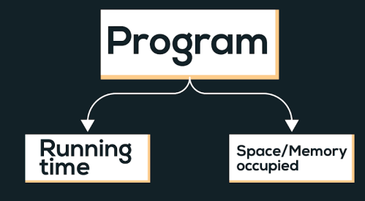

Time complexity of an algorithm quantifies the amount of time taken by an algorithm to run as a function of the length of the input.

Types of notations

1. O-notation: It is used to denote asymptotic upper bound. For a given function g(n), we denote it by O(g(n)). Pronounced as “big-oh of g of n”. It is also known as worst case time complexity as it denotes the upper bound in which the algorithm terminates.

2. Ω-notation: It is used to denote asymptotic lower bound. For a given function g(n), we denote it by Ω(g(n)). Pronounced as “big-omega of g of n”. It is also known as best case time complexity as it denotes the lower bound in which the algorithm terminates.

3. 𝚯-notation: It is used to denote the average time of a program.

**Examples:**  
  
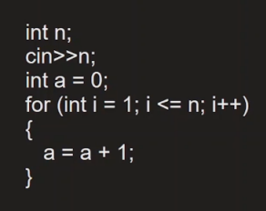

Linear Time Complexity. O(n)

**Comparison of functions on the basis of time complexity**

It follows the following order in case of time complexity:

O(nn) > O(n!) > O(n3) > O(n2) > O(n.log(n)) > O(n.log(log(n))) > O(n) > O(sqrt(n)) > O(log(n)) > O(1)

Note: Reverse is the order for better performance of a code with corresponding time complexity, i.e. a program with less time complexity is more efficient.

**Space Complexity**

Space complexity of an algorithm quantifies the amount of time taken by a program to run as a function of length of the input. It is directly proportional to the largest memory your program acquires at any instance during run time.

For example: *int* consumes 4 bytes of memory.

**Java - Introduction to Programming**

**Lecture 10**

**Arrays In Java**

Arrays in Java are like a list of elements of the same type i.e. a list of integers, a list of Booleans etc.

1. Creating an Array (method 1) - with new keyword

int[] marks = new int[3];

marks[0] = 97;

marks[1] = 98;

marks[2] = 95;

1. Creating an Array (method 2)

**int[] marks = {98, 97, 95};**

1. Taking an array as an input and printing its elements.

import java.util.*;

public class Arrays {

   public static void main(String args[]) {

       Scanner sc = new Scanner(System.in);

       int size = sc.nextInt();

       int numbers[] = new int[size];

       for(int i=0; i<size; i++) {

           numbers[i] = sc.nextInt();

       }

       //print the numbers in array

       for(int i=0; i<arr.length; i++) {

           System.out.print(numbers[i]+" ");

       }

   }

}

**Homework Problems**

1. Take an array of names as input from the user and print them on the screen.

import java.util.*;

public class Arrays {

   public static void main(String args[]) {

      Scanner sc = new Scanner(System.in);

      int size = sc.nextInt();

      String names[] = new String[size];

      //input

      for(int i=0; i<size; i++) {

          names[i] = sc.next();

      }

      //output

       for(int i=0; i<names.length; i++) {

           System.out.println("name " + (i+1) +" is : " + names[i]);

       }

   }

}

1. Find the maximum & minimum number in an array of integers.

[HINT: Read about Integer.MIN_VALUE & Integer.MAX_VALUE in Java]

import java.util.*;

public class Arrays {

   public static void main(String args[]) {

      Scanner sc = new Scanner(System.in);

      int size = sc.nextInt();

      int numbers[] = new int[size];

      //input

      for(int i=0; i<size; i++) {

          numbers[i] = sc.nextInt();

      }

      int max = Integer.MIN_VALUE;

      int min = Integer.MAX_VALUE;

       for(int i=0; i<numbers.length; i++) {

           if(numbers[i] < min) {

               min = numbers[i];

           }

           if(numbers[i] > max) {

               max = numbers[i];

           }

       }

       System.out.println("Largest number is : " + max);

       System.out.println("Smallest number is : " + min);

   }

}

1. Take an array of numbers as input and check if it is an array sorted in ascending order.

Eg: { 1, 2, 4, 7 } is sorted in ascending order.

       {3, 4, 6, 2} is not sorted in ascending order.

import java.util.*;

public class Arrays {

   public static void main(String args[]) {

      Scanner sc = new Scanner(System.in);

      int size = sc.nextInt();

      int numbers[] = new int[size];

      //input

      for(int i=0; i<size; i++) {

          numbers[i] = sc.nextInt();

      }

      boolean isAscending = true;

       for(int i=0; i<numbers.length-1; i++) { // NOTICE numbers.length - 1 as termination condition

           if(numbers[i] > numbers[i+1]) { // This is the condition for descending order

               isAscending = false;

           }

       }

       if(isAscending) {

           System.out.println("The array is sorted in ascending order");

       } else {

           System.out.println("The array is not sorted in ascending order");

       }

   }

}

**Java - Introduction to Programming**

**Lecture 11**

**2D Arrays in Java**

It is similar to 2D matrices that we studied in 11th and 12th class.

1. Creating a 2D Array - with new keyword

int[][] marks = new int[3][3];

1. Taking a matrix as an input and printing its elements.

import java.util.*;

public class TwoDArrays {

   public static void main(String args[]) {

       Scanner sc = new Scanner(System.in);

       int rows = sc.nextInt();

       int cols = sc.nextInt();

       int[][] numbers = new int[rows][cols];

       //input

       //rows

       for(int i=0; i<rows; i++) {

           //columns

           for(int j=0; j<cols; j++) {

               numbers[i][j] = sc.nextInt();

           }

       }

       for(int i=0; i<rows; i++) {

           for(int j=0; j<cols; j++) {

                   System.out.print(numbers[i][j]+" ");

               }

               System.out.println();

           }

   }

}

1. Searching for an element x in a matrix.

**import java.util.*;**

**public class TwoDArrays {**

**public static void main(String args[]) {**

**Scanner sc = new Scanner(System.in);**

**int rows = sc.nextInt();**

**int cols = sc.nextInt();**

**int[][] numbers = new int[rows][cols];**

**//input**

**//rows**

**for(int i=0; i<rows; i++) {**

**//columns**

**for(int j=0; j<cols; j++) {**

**numbers[i][j] = sc.nextInt();**

**}**

**}**

**int x = sc.nextInt();**

**for(int i=0; i<rows; i++) {**

**for(int j=0; j<cols; j++) {**

**//compare with x**

**if(numbers[i][j] == x) {**

**System.out.println("x found at location (" + i + ", " + j + ")");**

**}**

**}**

**}**

**}**

**}**

**Homework Problems**

1. Print the spiral order matrix as output for a given matrix of numbers. [Difficult for Beginners]  
   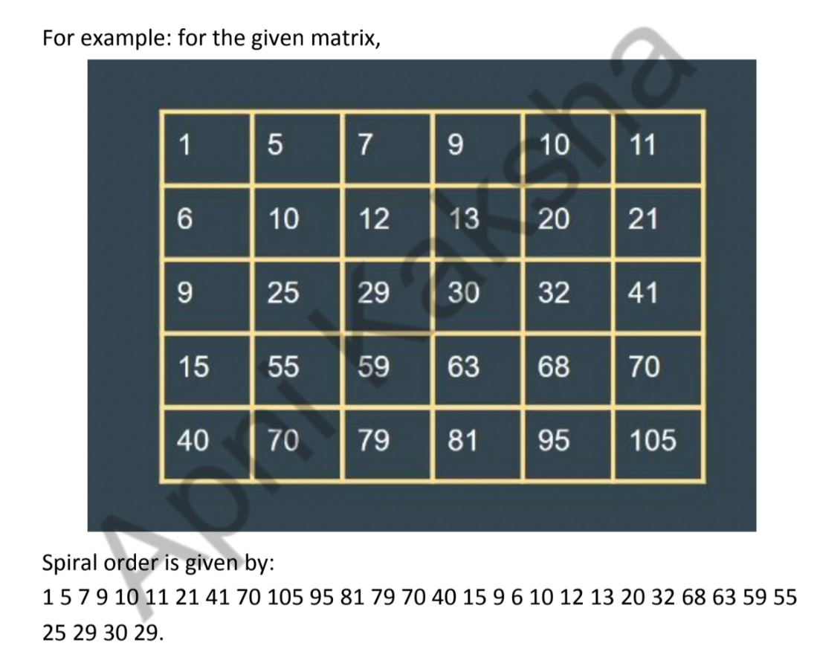

**APPROACH**:

Algorithm: (We are given a 2D matrix of n X m).

*1. We will need 4 variables:*

*a. row_start - initialized with 0.*

*b. row_end - initialized with n-1.*

*c. column_start - initialized with 0.*

*d. column_end - initialized with m-1.*

*2. First of all, we will traverse in the row row_start from column_start*

*to column_end and we will increase the row_start with 1 as we have*

*traversed the starting row.*

*3. Then we will traverse in the column column_end from row_start to*

*row_end and decrease the column_end by 1.*

*4. Then we will traverse in the row row_end from column_end to*

*column_start and decrease the row_end by 1.*

*5. Then we will traverse in the column column_start from row_end to*

*row_start and increase the column_start by 1.*

*6. We will do the above steps from 2 to 5 until row_start <= row_end*

*and column_start <= column_end.*

import java.util.*;

public class Arrays {

   public static void main(String args[]) {

      Scanner sc = new Scanner(System.in);

      int n = sc.nextInt();

      int m = sc.nextInt();

      int matrix[][] = new int[n][m];

      for(int i=0; i<n; i++) {

           for(int j=0; j<m; j++) {

               matrix[i][j] = sc.nextInt();

           }

      }

      System.out.println("The Spiral Order Matrix is : ");

      int rowStart = 0;

      int rowEnd = n-1;

      int colStart = 0;

      int colEnd = m-1;

      //To print spiral order matrix

      while(rowStart <= rowEnd && colStart <= colEnd) {

          //1

          for(int col=colStart; col<=colEnd; col++) {

              System.out.print(matrix[rowStart][col] + " ");

          }

          rowStart++;

          //2

          for(int row=rowStart; row<=rowEnd; row++) {

              System.out.print(matrix[row][colEnd] +" ");

          }

          colEnd--;

          //3

          for(int col=colEnd; col>=colStart; col--) {

              System.out.print(matrix[rowEnd][col] + " ");

          }

          rowEnd--;

          //4

          for(int row=rowEnd; row>=rowStart; row--) {

              System.out.print(matrix[row][colStart] + " ");

          }

          colStart++;

          System.out.println();

      }

   }

}

1. For a given matrix of N x M, print its transpose.

import java.util.*;

public class Arrays {

   public static void main(String args[]) {

      Scanner sc = new Scanner(System.in);

      int n = sc.nextInt();

      int m = sc.nextInt();

      int matrix[][] = new int[n][m];

      for(int i=0; i<n; i++) {

           for(int j=0; j<m; j++) {

               matrix[i][j] = sc.nextInt();

           }

      }

      System.out.println("The transpose is : ");

      //To print transpose

      for(int j=0; j<m ;j++) {

          for(int i=0; i<n; i++) {

              System.out.print(matrix[i][j]+" ");

          }

          System.out.println();

      }

   }

}

**Java - Introduction to Programming**

**Lecture 12**

**Strings**

**Declaration**

**String name = "Tony";**

**Taking Input**

**Scanner sc = new Scanner(System.in);**

**String name = sc.next();**

**Concatenation (Joining 2 strings)**

**String firstName = "Tony";**

**String secondName = "Stark";**

**String fullName = firstName + " " + secondName;**

**System.out.println(fullName);**

**Print length of a String**

**String firstName = "Tony";**

**String secondName = "Stark";**

**String fullName = firstName + " " + secondName;**

**System.out.println(fullName.length());**

**Access characters of a string**

**String firstName = "Tony";**

**String secondName = "Stark";**

**String fullName = firstName + " " + secondName;**

**for(int i=0; i<fullName.length(); i++) {**

**System.out.println(fullName.charAt(i));**

**}**

**Compare 2 strings**

**import java.util.*;**

**public class Strings {**

**public static void main(String args[]) {**

**String name1 = "Tony";**

**String name2 = "Tony";**

**if(name1.equals(name2)) {**

**System.out.println("They are the same string");**

**} else {**

**System.out.println("They are different strings");**

**}**

**//DO NOT USE == to check for string equality**

**//Gives correct answer here**

**if(name1 == name2) {**

**System.out.println("They are the same string");**

**} else {**

**System.out.println("They are different strings");**

**}**

**//Gives incorrect answer here**

**if(new String("Tony") == new String("Tony")) {**

**System.out.println("They are the same string");**

**} else {**

**System.out.println("They are different strings");**

**}**

**}**

**}**

**Substring**

The substring of a string is a subpart of it.

public class Strings {

   public static void main(String args[]) {

       String name = "TonyStark";

       System.out.println(name.substring(0, 4));

   }

}

**ParseInt Method of Integer class**

**public class Strings {**

**public static void main(String args[]) {**

**String str = "123";**

**int number = Integer.parseInt(str);**

**System.out.println(number);**

**}**

**}**

**ToString Method of String class**

**public class Strings {**

**public static void main(String args[]) {**

**int number = 123;**

**String str = Integer.toString(number);**

**System.out.println(str.length());**

**}**

**}**

**ALWAYS REMEMBER: Java Strings are Immutable.**

**Homework Problems**

1. Take an array of Strings input from the user & find the cumulative (combined) length of all those strings.

import java.util.*;

public class Strings {

   public static void main(String args[]) {

     Scanner sc = new Scanner (System.in);

     int size = sc.nextInt();

     String array[] = new String[size];

     int totLength = 0;

     for(int i=0; i<size; i++) {

       array[i] = sc.next();

       totLength += array[i].length();

     }

     System.out.println(totLength);

   }

}

1. Input a string from the user. Create a new string called ‘result’ in which you will replace the letter ‘e’ in the original string with letter ‘i’.

Example:

original = “eabcdef’; result = “iabcdif”

Original = “xyz”; result = “xyz”

import java.util.*;

public class Strings {

   public static void main(String args[]) {

     Scanner sc = new Scanner (System.in);

     String str = sc.next();

     String result = "";

     for(int i=0; i<str.length(); i++) {

       if(str.charAt(i) == 'e') {

         result += 'i';

       } else {

         result += str.charAt(i);

       }

     }

     System.out.println(result);

   }

}

1. Input an email from the user. You have to create a username from the email by deleting the part that comes after ‘@’. Display that username to the user.

Example:

email = “[apnaCollegeJava@gmail.com](mailto:apnacollegeJava@gmail.com)”; username = “apnaCollegeJava”

email = “[helloWorld123@gmail.com](mailto:helloWorlds123@gmail.com)”; username = “helloWorld123”

import java.util.*;

public class Strings {

   public static void main(String args[]) {

     Scanner sc = new Scanner (System.in);

     String email = sc.next();

     String userName = "";

     for(int i=0; i<email.length(); i++) {

       if(email.charAt(i) == '@') {

        break;

       } else {

         userName += email.charAt(i);

       }

     }

     System.out.println(userName);

   }

}

**Java - Introduction to Programming**

**Lecture 13**

**String Builder**

**Declaration**

**StringBuilder sb = new StringBuilder("Apna College");**

**System.out.println(sb);**

**Get A Character from Index**

**StringBuilder sb = new StringBuilder("Tony");**

**//Set Char**

**System.out.println(sb.charAt(0));**

**Set a Character at Index**

**StringBuilder sb = new StringBuilder("Tony");**

**//Get Char**

**sb.setCharAt(0, 'P');**

**System.out.println(sb);**

**Insert a Character at Some Index**

**import java.util.*;**

**public class Strings {**

**public static void main(String args[]) {**

**StringBuilder sb = new StringBuilder("tony");**

**//Insert char**

**sb.insert(0, 'S');**

**System.out.println(sb);**

**}**

**}**

**Delete char at some Index**

**import java.util.*;**

**public class Strings {**

**public static void main(String args[]) {**

**StringBuilder sb = new StringBuilder("tony");**

**//Insert char**

**sb.insert(0, 'S');**

**System.out.println(sb);**

**//delete char**

**sb.delete(0, 1);**

**System.out.println(sb);**

**}**

**}**

**Append a char**

Append means to add something at the end.

import java.util.*;

public class Strings {

   public static void main(String args[]) {

     StringBuilder sb = new StringBuilder("Tony");

     sb.append(" Stark");

     System.out.println(sb);

   }

}

**Print Length of String**

**import java.util.*;**

**public class Strings {**

**public static void main(String args[]) {**

**StringBuilder sb = new StringBuilder("Tony");**

**sb.append(" Stark");**

**System.out.println(sb);**

**System.out.println(sb.length());**

**}**

**}**

**Reverse a String (using StringBuilder class)**

**import java.util.*;**

**public class Strings {**

**public static void main(String args[]) {**

**StringBuilder sb = new StringBuilder("HelloWorld");**

**for(int i=0; i<sb.length()/2; i++) {**

**int front = i;**

**int back = sb.length() - i - 1;**

**char frontChar = sb.charAt(front);**

**char backChar = sb.charAt(back);**

**sb.setCharAt(front, backChar);**

**sb.setCharAt(back, frontChar);**

**}**

**System.out.println(sb);**

**}**

**}**

**Homework Problems**

Try Solving all the String questions with StringBuilder.

**Java - Introduction to Programming**

**Lecture 14**

**Bit Manipulation**

**Get Bit**

**import java.util.*;**

**public class Bits {**

**public static void main(String args[]) {**

**int n = 5; //0101**

**int pos = 3;**

**int bitMask = 1<<pos;**

**if((bitMask & n) == 0) {**

**System.out.println("bit was zero");**

**} else {**

**System.out.println("bit was one");**

**}**

**}**

**}**

**Set Bit**

**import java.util.*;**

**public class Bits {**

**public static void main(String args[]) {**

**int n = 5; //0101**

**int pos = 1;**

**int bitMask = 1<<pos;**

**int newNumber = bitMask | n;**

**System.out.println(newNumber);**

**}**

**}**

**Clear Bit**

**import java.util.*;**

**public class Bits {**

**public static void main(String args[]) {**

**int n = 5; //0101**

**int pos = 2;**

**int bitMask = 1<<pos;**

**int newBitMask = ~(bitMask);**

**int newNumber = newBitMask & n;**

**System.out.println(newNumber);**

**}**

**}**

**Update Bit**

import java.util.*;

public class Bits {

   public static void main(String args[]) {

       Scanner sc = new Scanner(System.in);

       int oper = sc.nextInt();

       // oper=1 -> set; oper=0 -> clear

      int n = 5;

      int pos = 1;

      int bitMask = 1<<pos;

      if(oper == 1) {

          //set

          int newNumber = bitMask | n;

          System.out.println(newNumber);

      } else {

       //clear

       int newBitMask = ~(bitMask);

       int newNumber = newBitMask & n;

       System.out.println(newNumber);

      }

   }

}

**Homework Problems**

1. Write a program to find if a number is a power of 2 or not.
2. Write a program to toggle a bit a position = “pos” in a number “n”.
3. Write a program to count the number of 1’s in a binary representation of the number.
4. Write 2 functions => decimalToBinary() & binaryToDecimal() to convert a number from one number system to another. [BONUS]

**Sorting in JAVA**

1. **Bubble Sort**

Idea: if arr[i] > arr[i+1] swap them. To place the element in their respective position, we have to do the following operation N-1 times.

Time Complexity: O(N2)

**Code**

import java.util.*;

class Sorting {

   public static void printArray(int arr[]) {

       for(int i=0; i<arr.length; i++) {

           System.out.print(arr[i]+" ");

       }

       System.out.println();

   }

   public static void main(String args[]) {

       int arr[] = {7, 8, 1, 3, 2};

       //bubble sort

       for(int i=0; i<arr.length-1; i++) {

           for(int j=0; j<arr.length-i-1; j++) {

               if(arr[j] > arr[j+1]) {

                   //swap

                   int temp = arr[j];

                   arr[j] = arr[j+1];

                   arr[j+1] = temp;

               }

           }

       }

       printArray(arr);

   }

}

1. **Selection Sort**

Idea: The inner loop selects the minimum element in the unsorted array and places the elements in increasing order.

Time complexity: O(N2)

**Code**

**import java.util.*;**

**class Sorting {**

**public static void printArray(int arr[]) {**

**for(int i=0; i<arr.length; i++) {**

**System.out.print(arr[i]+" ");**

**}**

**System.out.println();**

**}**

**public static void main(String args[]) {**

**int arr[] = {7, 8, 1, 3, 2};**

**//selection sort**

**for(int i=0; i<arr.length-1; i++) {**

**int smallest = i;**

**for(int j=i+1; j<arr.length; j++) {**

**if(arr[j] < arr[smallest]) {**

**smallest = j;**

**}**

**}**

**//swap**

**int temp = arr[smallest];**

**arr[smallest] = arr[i];**

**arr[i] = temp;**

**}**

**printArray(arr);**

**}**

**}**

1. **Insertion Sort**

Idea: Take an element from the unsorted array, place it in its corresponding position in the sorted part, and shift the elements accordingly.

Time Complexity: O(N2)

**Code**

**import java.util.*;**

**class Sorting {**

**public static void printArray(int arr[]) {**

**for(int i=0; i<arr.length; i++) {**

**System.out.print(arr[i]+" ");**

**}**

**System.out.println();**

**}**

**public static void main(String args[]) {**

**int arr[] = {7, 8, 1, 3, 2};**

**//insertion sort**

**for(int i=1; i<arr.length; i++) {**

**int current = arr[i];**

**int j = i - 1;**

**while(j >= 0 && arr[j] > current) {**

**//Keep swapping**

**arr[j+1] = arr[j];**

**j--;**

**}**

**arr[j+1] = current;**

**}**

**printArray(arr);**

**}**

**}**

1. **Quick Sort**

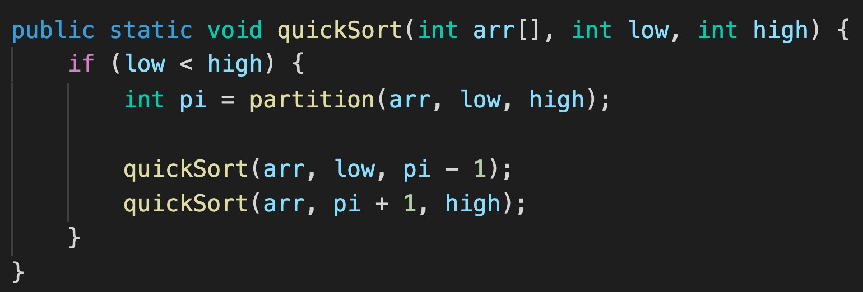

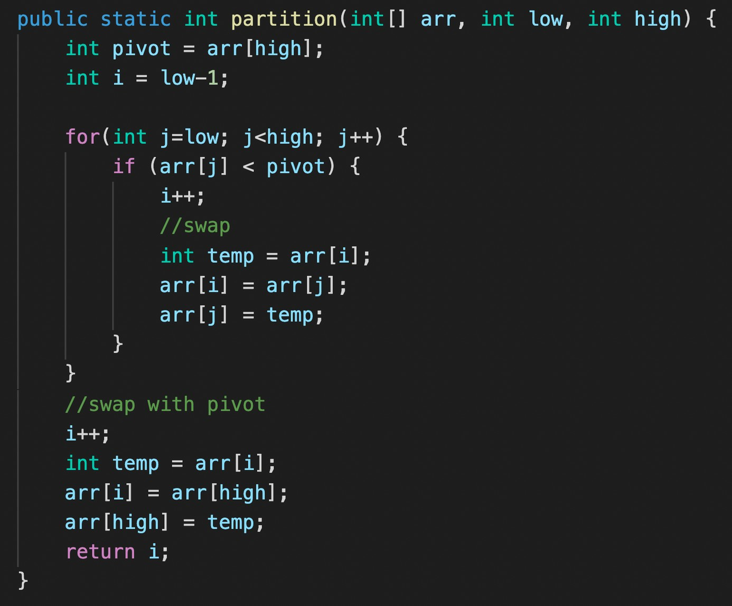

**Time complexity: -**

**Average = O(nlogn)**

**Worst = O(n^2)**

1. **Merge Sort**

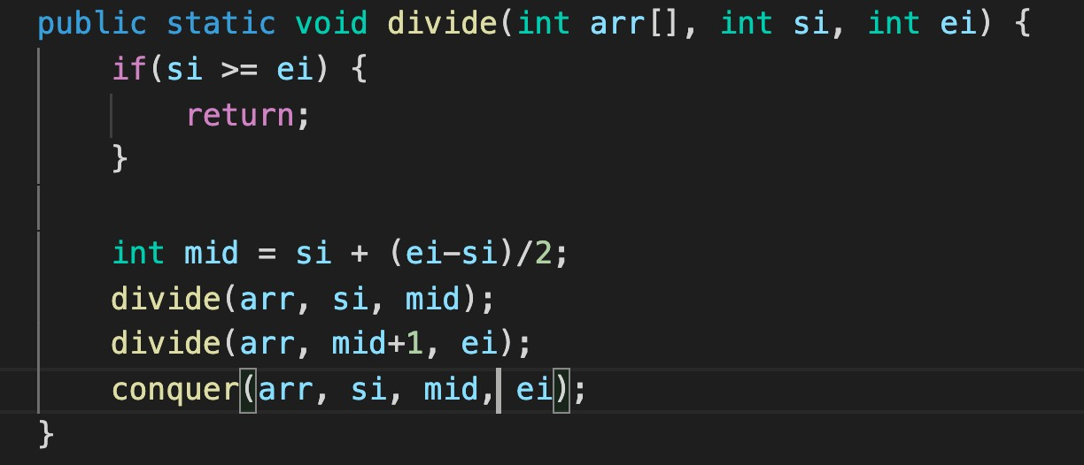

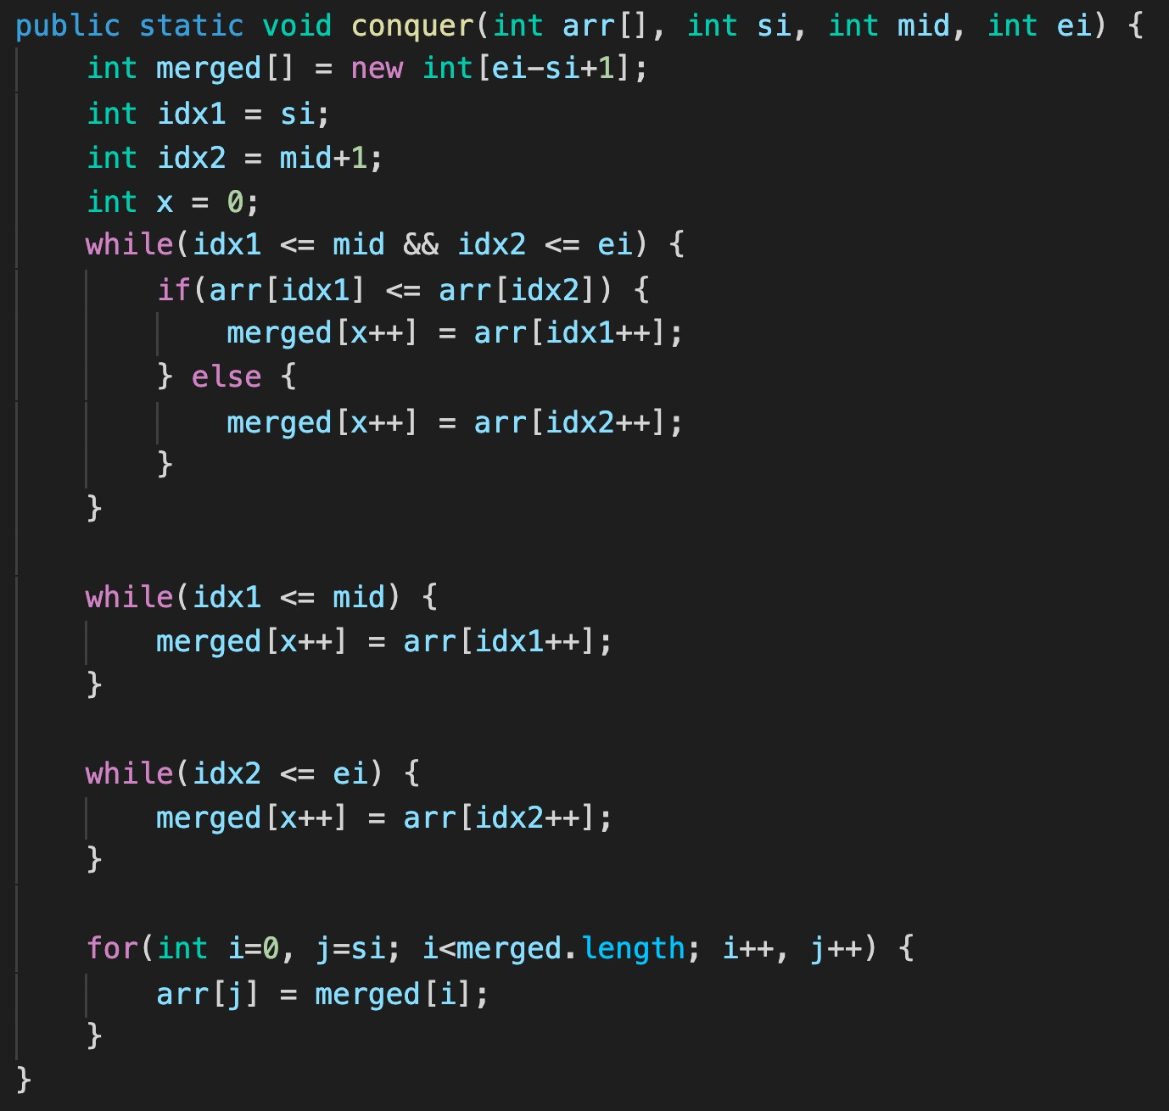**Time complexity: - O(nlogn)**

**JAVA Recursion Class 1 (Codes)**

Q1. Print numbers from 5 to 1.

public static void printNumbers(int n) {

if(n == 0) {

return;

}

System.out.println(n);

printNumbers(n-1);

}

Q2. Print numbers from 1 to 5.

public static void printNumbers(int n) {

if(n == 6) {

return;

}

System.out.println(n);

printNumbers(n+1);

}

Q3. Print the sum of first n natural numbers.

class Recursion1 {

public static void printSum(int n, int sum) {

if(n == 0) {

System.out.println(sum);

return;

}

sum += n;

printSum(n-1, sum);

}

public static void main(String args[]) {

printSum(5, 0);

}

}

Q4. Print factorial of a number n.

class Recursion1 {

public static void printFactorial(int n, int fact) {

if(n == 0) {

System.out.println(fact);

return;

}

fact *= n;

printFactorial(n-1, fact);

}

public static void main(String args[]) {

printFactorial(5, 1);

}

}

Q5. Print the fibonacci sequence till nth term.

class Recursion1 {

public static void printFactorial(int a, int b, int n) {

if(n == 0) {

return;

}

System.out.println(a);

printFactorial(b, a+b, n-1);

}

public static void main(String args[]) {

printFactorial(0, 1, 5);

}

}

Q6. Print x^n (with stack height = n)

class Recursion1 {

public static int printPower(int x, int n) {

if(n == 0) {

return 1;

}

if(x == 0) {

return 0;

}

int x_ = printPower(x, n-1);

int xn = x * x_;

return xn;

}

public static void main(String args[]) {

int x = 2, n = 5;

int output = printPower(x, n);

System.out.println(output);

}

}

Q7. Print x^n (with stack height = logn)

class Recursion1 {

public static int printPower(int x, int n) {

if(n == 0) {

return 1;

}

if(n % 2 == 0) {

return printPower(x, n/2) * printPower(x, n/2);

}

else {

return x * printPower(x, n/2) * printPower(x, n/2);

}

}

public static void main(String args[]) {

int x = 2, n = 5;

int output = printPower(x, n);

System.out.println(output);

}

}

**Recursion Class 2**

**Q1. Tower of Hanoi - Transfer n disks from source to destination over 3 towers.**

public class Recursion2 {

public static void towerOfHanoi(int n, String src, String helper, String dest) {

if(n == 1) {

System.out.println("transfer disk " + n + " from " + src + " to " + dest);

return;

}

//transfer top n-1 from src to helper using dest as 'helper'

towerOfHanoi(n-1, src, dest, helper);

//transfer nth from src to dest

System.out.println("transfer disk " + n + " from " + src + " to " + helper);

//transfer n-1 from helper to dest using src as 'helper'

towerOfHanoi(n-1, helper, src, dest);

}

public static void main(String args[]) {

int n = 4;

towerOfHanoi(n, "A", "B", "C");

}

}

**Q2. Print a string in reverse.**

public class Recursion2 {

public static String revString(String str) {

if(str.length() == 1) {

return str;

}

char currChar = str.charAt(0);

String nextString = revString(str.substring(1));

return nextString + currChar;

}

public static void main(String args[]) {

String str = "abcd";

String reversed = revString(str);

System.out.println(reversed);

}

}

**Q3. Find the occurrence of the first and last occurrence of an element using recursion.**

public class Recursion2 {

public static int first = -1;

public static int last = -1;

public static void getIndices(String str, char el, int idx) {

if(idx == str.length()) {

return;

}

if(str.charAt(idx) == el) {

if(first == -1) {

first = idx;

} else {

last = idx;

}

}

getIndices(str, el, idx+1);

}

public static void main(String args[]) {

String str = "tabcdfghijakkk";

char el = 'a';

getIndices(str, el, 0);

System.out.println("First occurence : " + first);

System.out.println("Last occurence : " + last);

}

}

**Q4. Check if an array is sorted (strictly increasing). - O(n)**

public class Recursion2 {

public static boolean checkIfIncreasing(int arr[], int idx) {

if(idx == arr.length-1) {

return true;

}

if(!checkIfIncreasing(arr, idx+1)) {

return false;

}

return arr[idx] < arr[idx + 1];

}

public static void main(String args[]) {

int arr1[] = {1, 2, 3, 4, 5};

int arr2[] = {1, 6, 3, 4, 5};

if(checkIfIncreasing(arr2, 0)) {

System.out.println("Strictly Increasing");

} else {

System.out.println("NOT Strictly Increasing");

}

}

}

**Q5. Move all ‘x’ to the end of the string. - O(n)**

public class Recursion2 {

//to add all 'x' to the end of the string

public static String addX(int count) {

String newStr = "x";

for(int i=1;i<count; i++) {

newStr += 'x';

}

return newStr;

}

public static String moveAllX(String str, int idx, int count) {

if(idx == str.length()) {

return addX(count);

}

if(str.charAt(idx) == 'x') {

return moveAllX(str, idx+1, count+1);

} else {

String nextStr = moveAllX(str, idx+1, count);

return str.charAt(idx) + nextStr;

}

}

public static void main(String args[]) {

String str = "abcdefxghxixjxxxk";

int count = 0;

String newStr = moveAllX(str, 0, count);

System.out.println(newStr);

}

}

**Q6. Remove duplicates in a string.**

public class Recursion2 {

public static String removeDuplicates(String str, int idx, boolean present[]) {

if(idx == str.length()) {

return "";

}

char curr = str.charAt(idx);

if(present[curr-'a']) {

return removeDuplicates(str, idx+1, present);

} else {

present[curr-'a'] = true;

return curr + removeDuplicates(str, idx+1, present);

}

}

public static void main(String args[]) {

String str = "abcadbcefghabi";

boolean present[] = new boolean[str.length()];

System.out.println(removeDuplicates(str, 0, present));

}

}

**Q7. Print all the subsequences of a string.**

public class Recursion2 {

public static void printSubseq(String str, int idx, String res) {

if(idx == str.length()) {

System.out.println(res);

return;

}

//choose

printSubseq(str, idx+1, res+str.charAt(idx));

//don't choose

printSubseq(str, idx+1, res);

}

public static void main(String args[]) {

String str1 = "abc";

String str2 = "aaa";

printSubseq(str1, 0, "");

}

}

Time complexity - O(2^n)

**Q8. Print all unique subsequences of a string.**

import java.util.HashSet;

public class Recursion2 {

public static void printSubseq(String str, int idx, String res, HashSet<String>

allSubseq) {

if(idx == str.length()) {

if(allSubseq.contains(res)) {

return;

}

allSubseq.add(res);

System.out.println(res);

return;

}

//choose

printSubseq(str, idx+1, res+str.charAt(idx), allSubseq);

//don't choose

printSubseq(str, idx+1, res, allSubseq);

}

public static void main(String args[]) {

String str1 = "abc";

String str2 = "aaa";

HashSet<String> allSubseq = new HashSet<>();

printSubseq(str2, 0, "", allSubseq);

}

}

**Q9. Print keypad combination**

( 0 -> .;

1 -> abc

2 -> def

3 -> ghi

4 -> jkl

5 -> mno

6 -> pqrs

7 -> tu

8 -> vwx

9 -> yz

)

import java.util.HashSet;

public class Recursion2 {

public static String keypad[] = {".", "abc", "def", "ghi", "jkl", "mno", "pqrs",

"tu", "vwx", "yz"};

public static void printKeypadCombination(String number, int idx, String res) {

if(idx == number.length()) {

System.out.println(res);

return;

}

for(int i=0; i<keypad[number.charAt(idx)-'0'].length(); i++) {

char curr = keypad[number.charAt(idx)-'0'].charAt(i);

printKeypadCombination(number, idx+1, res+curr);

}

}

public static void main(String args[]) {

String number = "23";

printKeypadCombination(number, 0, "");

}

}

**Recursion ADVANCED**

Q1. Print all the permutations of a string.

public class Recursion3 {

   public static void printPermutation(String str, int idx, String perm) {

       if(str.length() == 0) {

           System.out.println(perm);

           return;

       }

       for(int i=0; i<str.length(); i++) {

           char currChar = str.charAt(i);

           String newStr = str.substring(0, i) + str.substring(i+1);

           printPermutation(newStr, idx+1, perm+currChar);

       }

   }

   public static void main(String args[]) {

       String str = "abc";

       printPermutation(str, 0, "");

   }

}

Time complexity - O(n*n!)

Q2. Count Path Maze

public class Recursion3 {

   public static int countPaths(int i, int j, int m, int n) {

       if(i == m-1 || j == n-1) {

           return 1;

       }

       return countPaths(i+1, j, m, n) + countPaths(i, j+1, m, n);

   }

   public static void main(String args[]) {

       int m = 4, n = 5;

       System.out.println(countPaths(0, 0, m, n));

   }

}

Time complexity - O(2^(m+n))

Q3. Tiling problem

public class Recursion3 {

   public static int placeTiles(int n, int m) {

       if(n < m) {

           return 1;

       } else if(n == m) {

           return 2;

       }

       return placeTiles(n-1, m) + placeTiles(n-m, m);

   }

   public static void main(String args[]) {

       int n = 4, m = 4;

       System.out.println(placeTiles(n, m));

   }

}

Q4. Friends pairing problem

public class Recursion3 {

   public static int pairFriends(int n) {

      if(n <= 1) {

          return 1;

      }

       return pairFriends(n-1) + (n-1) * pairFriends(n-2);

   }

   public static void main(String args[]) {

       int n = 3;

       System.out.println(pairFriends(n));

   }

}

Q5. Subsets of a set

import java.util.ArrayList;

public class Recursion3 {

   public static void printSubsets(ArrayList<Integer> subset) {

       for(int i=0; i<subset.size(); i++) {

           System.out.print(subset.get(i)+" ");

       }

       System.out.println();

   }

   public static void findSubsets(int n, ArrayList<Integer> subset) {

       if(n == 0) {

           printSubsets(subset);

           return;

       }

       findSubsets(n-1, subset);

       subset.add(n);

       findSubsets(n-1, subset);

       subset.remove(subset.size() - 1);

   }

   public static void main(String args[]) {

       int n = 3;

       findSubsets(n, new ArrayList<Integer> ());

   }

}

**Backtracking in Recursion**

**Java**

**Print all Permutations**

Time complexity - O(n*n!)

public class Recursion3 {

   public static void printPermutation(String str, int idx, String perm) {

       if(str.length() == 0) {

           System.out.println(perm);

           return;

       }

       for(int i=0; i<str.length(); i++) {

           char currChar = str.charAt(i);

           String newStr = str.substring(0, i) + str.substring(i+1);

           printPermutation(newStr, idx+1, perm+currChar);

       }

   }

   public static void main(String args[]) {

       String str = "abc";

       printPermutation(str, 0, "");

   }

}

**N-Queens**

Time complexity - O(n^n)

class Solution {

   public boolean isSafe(int row, int col, char[][] board) {

       //horizontal

       for(int j=0; j<board.length; j++) {

           if(board[row][j] == 'Q') {

               return false;

           }

       }

       //vertical

       for(int i=0; i<board.length; i++) {

           if(board[i][col] == 'Q') {

               return false;

           }

       }

       //upper left

       int r = row;

       for(int c=col; c>=0 && r>=0; c--, r--) {

           if(board[r][c] == 'Q') {

               return false;

           }

       }

       //upper right

       r = row;

       for(int c=col; c<board.length && r>=0; r--, c++) {

           if(board[r][c] == 'Q') {

               return false;

           }

       }

       //lower left

       r = row;

       for(int c=col; c>=0 && r<board.length; r++, c--) {

           if(board[r][c] == 'Q') {

               return false;

           }

       }

       //lower right

       for(int c=col; c<board.length && r<board.length; c++, r++) {

           if(board[r][c] == 'Q') {

               return false;

           }

       }

       return true;

   }

   public void saveBoard(char[][] board, List<List<String>> allBoards) {

       String row = "";

       List<String> newBoard = new ArrayList<>();

       for(int i=0; i<board.length; i++) {

           row = "";

           for(int j=0; j<board[0].length; j++) {

               if(board[i][j] == 'Q')

                   row += 'Q';

               else

                   row += '.';

           }

           newBoard.add(row);

       }

       allBoards.add(newBoard);

   }

   public void helper(char[][] board, List<List<String>> allBoards, int col) {

       if(col == board.length) {

           saveBoard(board, allBoards);

           return;

       }

       for(int row=0; row<board.length; row++) {

           if(isSafe(row, col, board)) {

               board[row][col] = 'Q';

               helper(board, allBoards, col+1);

               board[row][col] = '.';

           }

       }

   }

   public List<List<String>> solveNQueens(int n) {

       List<List<String>> allBoards = new ArrayList<>();

       char[][] board = new char[n][n];

       helper(board, allBoards, 0);

       return allBoards;

   }

}

**Homework Problems**

1. <https://leetcode.com/problems/permutations/> (Similar to print Permutations)
2. <https://www.hackerrank.com/challenges/knightl-on-chessboard/problem> (Similar to N-Queens)

<https://leetcode.com/problems/sudoku-solver/> (Will be discussed in next class)

**Sudoku Solver (Backtracking 2)**

**Java**

Write a program to solve a Sudoku puzzle by filling the empty cells.

A sudoku solution must satisfy all of the following rules:

1. Each of the digits 1-9 must occur exactly once in each row.
2. Each of the digits 1-9 must occur exactly once in each column.
3. Each of the digits 1-9 must occur exactly once in each of the 9 3x3 sub-boxes of the grid.

The '.' character indicates empty cells.

**Sample Input**

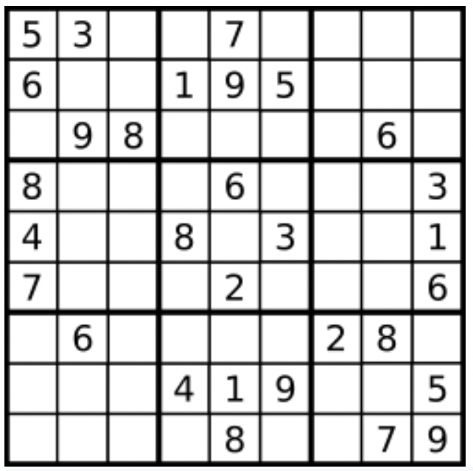

Board = [["5","3",".",".","7",".",".",".","."],["6",".",".","1","9","5",".",".","."],[".","9","8",".",".",".",".","6","."],["8",".",".",".","6",".",".",".","3"],["4",".",".","8",".","3",".",".","1"],["7",".",".",".","2",".",".",".","6"],[".","6",".",".",".",".","2","8","."],[".",".",".","4","1","9",".",".","5"],[".",".",".",".","8",".",".","7","9"]]

**Sample Output**

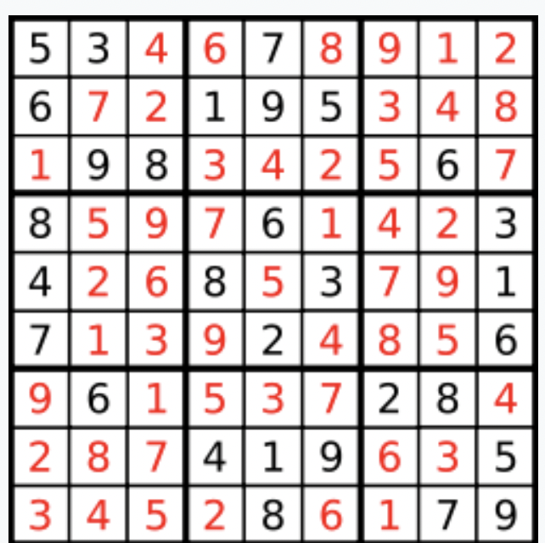

[["5","3","4","6","7","8","9","1","2"],["6","7","2","1","9","5","3","4","8"],["1","9","8","3","4","2","5","6","7"],["8","5","9","7","6","1","4","2","3"],["4","2","6","8","5","3","7","9","1"],["7","1","3","9","2","4","8","5","6"],["9","6","1","5","3","7","2","8","4"],["2","8","7","4","1","9","6","3","5"],["3","4","5","2","8","6","1","7","9"]]

**Code**

1. StartingRow = 3*(row/3) & StartingCol = 3*(col/3)
2. StartingRow = row - row%3 & StartingCol = col - col%3

**Code**

class Solution {

public boolean isSafe(char[][] board, int row, int col, int number) {

//column

for(int i=0; i<board.length; i++) {

if(board[i][col] == (char)(number+'0')) {

return false;

}

}

//row

for(int j=0; j<board.length; j++) {

if(board[row][j] == (char)(number+'0')) {

return false;

}

}

//grid

int sr = 3 * (row/3);

int sc = 3 * (col/3);

for(int i=sr; i<sr+3; i++) {

for(int j=sc; j<sc+3; j++) {

if(board[i][j] == (char)(number+'0')) {

return false;

}

}

}

return true;

}

public boolean helper(char[][] board, int row, int col) {

if(row == board.length) {

return true;

}

int nrow = 0;

int ncol = 0;

if(col == board.length-1) {

nrow = row + 1;

ncol = 0;

} else {

nrow = row;

ncol = col + 1;

}

if(board[row][col] != '.') {

if(helper(board, nrow, ncol)) {

return true;

}

} else {

//fill the place

for(int i=1; i<=9; i++) {

if(isSafe(board, row, col, i)) {

board[row][col] = (char)(i+'0');

if(helper(board, nrow, ncol))

return true;

else

board[row][col] = '.';

}

}

}

return false;

}

public void solveSudoku(char[][] board) {

helper(board, 0, 0);

}

}

**ArrayList in Java**

**Operations:**

1. **Declare an ArrayList of different Types**
2. **Add Element**
3. **Get Element**
4. **Add Element at a specific Index**
5. **Set Element at a specific Index**
6. **Delete Element from an Index**
7. **Size of the List**
8. **Loop/Iterate on the List**
9. **Sort the List**

**import java.util.ArrayList;**

**import java.util.Collections;**

**class ArrayLists {**

**public static void main(String args[]) {**

**ArrayList<Integer> list = new ArrayList<Integer>();**

**ArrayList<String> list2 = new ArrayList<String>();**

**ArrayList<Boolean> list3 = new ArrayList<Boolean>();**

**//add elements**

**list.add(1);**

**list.add(3);**

**list.add(4);**

**list.add(5);**

**System.out.println(list);**

**//to get an element**

**int element = list.get(0); // 0 is the index**

**System.out.println(element);**

**//add element in between**

**list.add(1,2); // 1 is the index and 2 is the element to be added**

**System.out.println(list);**

**//set element**

**list.set(0,0);**

**System.out.println(list);**

**//delete elements**

**list.remove(0); // 0 is the index**

**System.out.println(list);**

**//size of list**

**int size = list.size();**

**System.out.println(size);**

**//Loops on lists**

**for(int i=0; i<list.size(); i++) {**

**System.out.print(list.get(i) + " ");**

**}**

**System.out.println();**

**//Sorting the list**

**list.add(0);**

**Collections.sort(list);**

**System.out.println(list);**

**}**

**}**

**Homework Problems**

Try solving all problems of arrays with ArrayList.